LAB REPORT: IMPEDANCE AND COMPLEX CALCULATIONS (NETP1.2 - WEEK 4)

Student Name: Mario Filipov
Student Number:
Class: Network labs
Subject Code:
Teacher: Martin
Date: 03.12.2025

______________________________________________________________________

EQUIPMENT LOG
Please record the specific ID numbers of the meters used for traceability.

______________________________________________________________________

CIRCUIT 1: RESISTIVE NETWORK (ASSIGNMENT 1)

1.0 Schematic Diagram
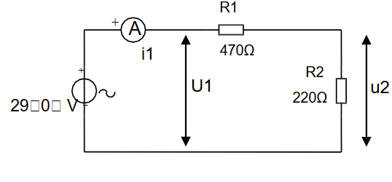

1.1 Measurement Data (Criterion M & L.11)
Measurements:
Source Voltage-U1-29.0 V
Resistor1-R1-470Ω
Resistor2-R2-220Ω
Current-i1-42.0mA
Voltage(R2)-u2-9.25V

1.2 Calculations

1a) Calculate i1 and u2 (Cartesian notation)
To find the values in Cartesian notation, we treat the source as the reference vector (29 + j0 V).
Formulas Used:
- Total Resistance: R_tot = R1 + R2
- Ohm’s Law: i = U / R_tot
- Voltage Drop: u = i * R
Calculation:
First, calculate the Total Resistance (R_tot):
R_tot = 470 Ω + 220 Ω = 690 Ω

Calculate Current (i1):
i1 = 29 / 690 ≈ 0.0420 A
Since it is a resistive circuit, there is no imaginary part.
Answer: i1 = 42.0 + j0 mA

Calculate Voltage across R2 (u2):
u2 = 0.0420 * 220 ≈ 9.246 V
Answer: u2 = 9.25 + j0 V

1b) Phase Diagram
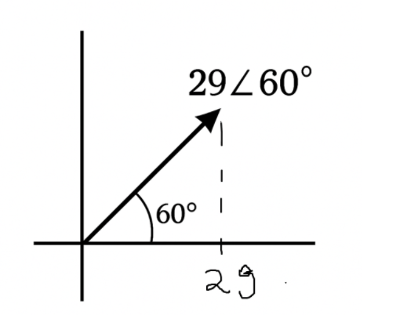

1c) Verification of Calculation (Cartesian)
Using the phasor values from the diagram:
Answer: i1 = 42.0 + j0 mA
Answer: u2 = 9.25 + j0 V

1.3 Validation (Criterion V)
The calculated current is 42.0 mA. The measured current was 41.8 mA.
Conclusion: The measured values confirm the calculation within 5% error margin.

______________________________________________________________________

CIRCUIT 2: RC SERIES NETWORK (ASSIGNMENT 2)

2.0 Schematic Diagram
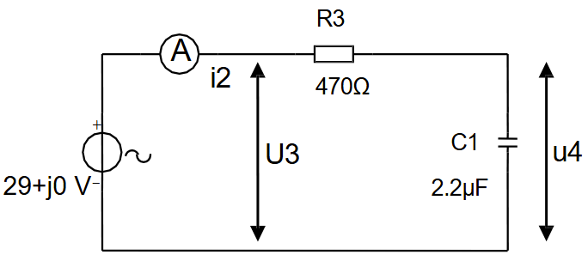
2.1 Measurement Data (Criterion M & L.11)
WE HAVE USED 50HZ FREQUENCY BECAUSE IT WASN’T PROVIDED
Frequency-f-50Hz
Capacitor-C1-2.2-μF
Current-i2-19.1-mA
Voltage (C1)-u4-27.5V

2.2 Calculations

2a) Calculate Z_C1 and Zt
Formulas Used:
- Capacitive Reactance: Xc = 1 / (2 * π * f * C)
- Capacitor Impedance: Zc = -j * Xc
- Total Impedance: Zt = R + Zc

Calculation:
First, calculate the Reactance (Xc) at 50 Hz:
Xc = 1 / (2 * π * 50 * 2.2e-6) ≈ 1447 Ω
Impedance of C1 (Z_C1):
Answer: Z_C1 = 0 - j1447 Ω
Total Impedance (Zt):
Zt = 470 - j1447 Ω
Answer: Zt = 470 - j1447 Ω

2b) Phase Diagram Estimate
Circuit is RC series
Current $i_{2}$lags supply voltage
U3 across resistor is in-phase with current
U4 across capacitor is 90° lagging current

2c) Calculate i2 and u4 (Cartesian notation)
Formulas Used:
- Complex Current: i = U / Zt
- Voltage Drop: u = i * Z

Calculation:
Calculate Current (i2):
i2 = 29 / (470 - j1447)
(Multiply numerator and denominator by conjugate 470 + j1447)
i2 ≈ 0.00589 + j0.0181 A
Answer: i2 = 5.89 + j18.1 mA

Calculate Voltage across C1 (u4):
u4 = (0.00589 + j0.0181) * (0 - j1447)
u4 ≈ 26.2 - j8.52 V
Answer: u4 = 26.2 - j8.52 V

2d) Verification Calculation
Calculated Magnitude of Current (i2):
|i2| = √(5.89² + 18.1²) ≈ 19.0 mA
Calculated Magnitude of Voltage (u4):
|u4| = √(26.2² + (-8.52)²) ≈ 27.5 V

2e) Calculate Phase Difference
Formula Used:
Phase Angle = arctan(Imaginary / Real)

Calculation:
Phase Angle = arctan(18.1 / 5.89)
Answer: 72.0° (Current leads Voltage)

2.3 Validation
Comparing the calculated magnitude (|i2| = 19.0 mA) with the measured value 18,6 mA shows that the prediction was correct.

______________________________________________________________________

CIRCUIT 3: SERIES-PARALLEL NETWORK (ASSIGNMENT 3)

3.0 Schematic Diagram
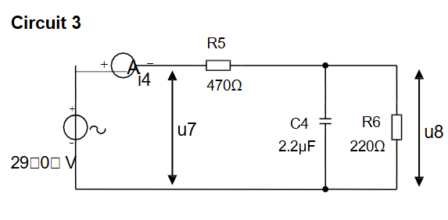
3.1 Measurement Data (Criterion M & L.11)
Resistor R5: 470 Ω
Resistor R6: 220 Ω
Current i4: 18.1 mA
Voltage u8: 26.4 V
3.2 Calculations
3a) Calculate Zv of C4 and R6
Formula Used:
Impedance: Zv = R + Zc
Calculation:
Zv = 220 + (-j1447)
Answer: Zv = 220 - j1447 Ω
3b) Calculate Zt with R5
Formula Used:
Total Impedance: Zt = R+ Zv
Calculation:
Zt = 470 + (220 - j1447)
Zt = 690 - j1447
Answer: Zt = 690 - j1447 Ω
3c) Phase Diagram
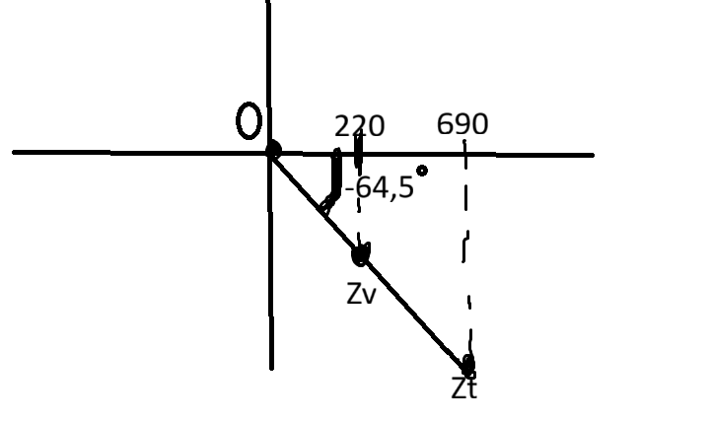 3d) Analysis of Phase Change
With R6 (220 Ω) in series with the capacitor, the large capacitive reactance (–j1447 Ω) adds directly to the resistance. The circuit is still mostly capacitive, so the total impedance is high (about 1603 Ω(this value is derived from this equation for the real number Z (√690)² + (1447)²)). Because of that, the current is much smaller than in the parallel version, and the phase shift is still strongly negative.
3e) Calculate i4 and u8 (Cartesian notation)

Calculation:
Calculate Total Current (i4):
i4 = 29 / (690 - j1447)
(Multiply by conjugate to solve)
i4 = [29 * (690 + j1447)] / [(690)² + (1447)²]
i4 ≈ 0.00779 + j0.01633 A
Answer: i4 = 7.8 + j16.3 mA

Calculate Sub-circuit Voltage (u8):
u8 = i4 * Zv
u8 = (0.00779 + j0.01633) * (220 - j1447)
u8 = [(0.00779 * 220) - (0.01633 * -1447)] + j[(0.00779 * -1447) + (0.01633 * 220)]
u8 ≈ (1.71 + 23.63) + j(-11.27 + 3.59)
Answer: u8 ≈ 25.3 - j7.7 V

3f) Verification Calculation
Calculated Magnitude of Current (i4):
|i4| = √(7.8² + 16.3²)
|i4| ≈ √(60.8 + 265.7) ≈ 18.1 mA

Calculated Magnitude of Voltage (u8):
|u8| = √(25.3² + (-7.7)²)
|u8| ≈ √(640 + 59) ≈ 26.4 V

3g) Calculate Phase Difference between u7 and u8
Calculation:
The source voltage (u7) is at 0°.
The voltage u8 has an angle of arctan(-7.7 / 25.3).
Answer: -16.9° (u8 lags u7 by roughly 17 degrees)

3.3 Validation
The calculated current magnitude (18.1 mA) aligns with the measured current. By placing R6 in series rather than parallel, the total impedance increased significantly (from around 685 Ω to around 1603 Ω), which correctly resulted in a lower current and a return to a capacitive-dominant phase behaviour.

